# A Synopsis on

**“Voice operated lift control system with safety”**



**Amrutvahini College of Engineering, Sangamner Electronics and Telecommunication Engineering**

Submitted by,

**Bhoknal Gayatri Satish (B.E., Roll Number: 07) Varpe Aditya Rajendra (B.E., Roll Number: 66) Waman Onkar Uttam (B.E., Roll Number: 69) Zanjare Shaileshkumar Gangaram(B.E., Roll Number: 72)**

**Submitted on: August, 2023**

**Amrutvahini College of Engineering, Sangamner Department of Electronics and Telecommunication Project Synopsis**

**Academic Year: 2023-24**

**Synopsis**

## Introduction

The history of elevators is long and fascinating. The first known elevator was invented by Archimedes in 236 BC. It was a simple hoist powered by human or animal labor. In 1852, Elisha Otis demonstrated the first safety-based elevator. This elevator had a brake that would engage if the cable broke, preventing the elevator from falling. Otis's invention revolutionized the elevator industry and made elevators safe for public use. In 1857, Otis installed the first passenger elevator in a New York City store. This elevator was powered by steam. In 1874, J.W. Meeker patented a method that allowed elevator doors to open and close safely. This invention made elevators more user-friendly and increased their efficiency. The first residential elevator was created by Clearance Conrad in 1929. This elevator was powered by electricity. In the 1950s, Otis introduced the Autotropic system, which was the first predictive elevator control system. This system could anticipate traffic patterns within a building and deploy elevators in the most efficient manner [1].

Blind people face many problems every day. One of these challenges is the use of elevators in many buildings. visually impaired should be able to enjoy using the elevator easily. Chapter To overcome this challenge for the blind, we must focus on the following issues: Make sure the blind person is at the elevator door Chapter Accept the idea of ​​getting down for the blind person Chapter Attention coming into the elevator from the seat of the blind person [2].

Speech is the superior personality of the human beings gifted by the nature. Speech helps to deliver the thoughts and messages between human. Speech recognition is the process of the computer recognizing human speech to generate a string of words or commands. Sometimes it is known as automatic speech recognition. Speech recognition is becoming more perplexing and difficult task. The speech recognition research is focuses mainly on large vocabulary, continuous speech capabilities and speaker independence. The design of speech recognition requires cautious attention to some issues like speech representation, depiction of various types of speech Classes, techniques, and database and performance evaluation [3].

A voice-operated elevator system is proposed where the user’s input commands to control the movement of the elevator system are kept convenient for the users. The commands include voice input for the floor operations, directions, elevator car’s door operation, and a special option to place a call of speaker’s choice in case of any unexpected event that requires immediate action [4].

**Amrutvahini College of Engineering, Sangamner**

**Department of Electronics and Telecommunication**

**Project Synopsis**

**Academic Year: 2023-24**

## Need of the Project

. The blind people cannot use the elevator easily. It is difficult to use the keypad if they cannot see it. Sometimes the keypad has Braille technique, but they will have hard time for locating its place. Even though they found the keypad, how can they know the number if they do not know Braille? The struggle of the blind people using elevators is real. They always need help in elevators from someone to press the button for them and to tell them when the elevator cabin arrives. Also, it is hard for them to know the elevator door is opening or closing. Not that only, but in case of emergency how they will act if there is no one with them to help [8]. So voice-controlled elevator can be a very good option for this people. One more drawback of the current lift is that it cannot tell on which floor the lift is stuck, nor the parameters like temperature of motor, fire detection inside the lift. But by using this voice operated lift we can solve all these problems. Also there is need to observe real-time status of lift parameters.

## Aim and Objectives

**Aim:** Design and development of a voice-controlled lift/elevator control system with enhanced security features for human-machine communication.

### Objectives:

* 1. To operate lift through voice commands with easy use for people with visual and physical challenges.
  2. To measure parameters like floor number, weight of the lift, fire detection, temperature of motor, etc.
  3. To give real time information of lift parameters on the webpage and sending emergency alert on respective webpage.

## Related work

There is a paper which shows need for biometric access in elevators, and the advantages of using vein fingerprints over other biometric modalities. The authors then present the design of their FPGA-based elevator controller, which is based on a finite state machine (FSM). The controller first authenticates the user's vein fingerprint, and then controls the elevator's movement based on the user's input. The paper also presents the results of simulation and testing of the controller, which show that it is secure, reliable, and efficient [1].

The proposed system uses two units as remote unit and elevator unit, both communicate wirelessly to transfer commands to the elevator unit. So basically one must carry this remote unit with himself while using the elevator. Here remote unit is responsible for speech recognition and playing command audio for the person using it and sensing command to lift unit [2].

**Amrutvahini College of Engineering, Sangamner**

**Department of Electronics and Telecommunication**

**Project Synopsis**

**Academic Year: 2023-24**

The paper proposes a system for controlling elevators using speech recognition for people with physical disabilities. The system is based on a Raspberry Pi 3B+ microcontroller and a Google Cloud Speech API. The system first recognizes the user's voice command, and then sends the command to the Raspberry Pi, which controls the elevator's movement [4].

This project represents the voice operated intelligent lift. This follows the principle of speech recognition. The lift is controlled by the user’s voice commands. This project is useful for paralyzed, blind, and physically challenged people [5].

So there is a project which uses a Bluetooth module to communicate between microcontroller and mobile phone, as this system uses google assistant from mobile for speech recognition and then microcontroller give controls to the motors of the elevator and other control circuits [9].

## Description and Block diagram

This is description of below block diagram. Here the rectifier is used as a component of power supply. The 230V AC is step down to 12V AC using transformer and is rectified to 12V DC by the rectifier. LM7805 is used as the voltage regulator, which regulates the voltage to 5V [6]. The voice recognition system is the main part of this project. Voice recognition module is communication mechanism between the user and microcontroller. The project will make the use of DC motor for the moving of lift. Microcontroller is programmed, with the help of embedded C programming. The microcontroller can communicate with all input and output modules of elevator.

The Wi-Fi module is used for the wireless connection between the server and controller. The microcontroller processes the received voice commands using a voice recognition module. Based on the recognized voice commands, the microcontroller's control logic will determine the appropriate actions to control the elevator, interfacing with the elevator's control circuitry and motor drivers to execute the commands accurately [7]. Load sensors placed within the elevator continuously monitor the weight of the carriage and passengers, ensuring that the elevator does not exceed its maximum weight capacity for safe operation.

The voice recognition module desires to be trained first earlier than it could be used to apprehend instructions. Upon a success recognition of voice command, the microcontroller drives the corresponding load with the assist of the relay circuit [10]. Additionally, the microcontroller incorporates safety mechanisms such as voice-activated emergency stop, weight limit warnings, and vocal confirmation of emergency messages to enhance passenger safety. The elevator's server integration allows for remote monitoring, and data visualization. Building administrators, maintenance personnel, and emergency response teams can remotely manage the elevator's operations, access real-time data, and optimize performance through a dedicated webpage. Overall, this voice-controlled elevator system provides an innovative, user-friendly, and safe elevator experience for passengers while optimizing energy efficiency and offering convenient remote management capabilities.

**Amrutvahini College of Engineering, Sangamner Department of Electronics and Telecommunication**

**Project Synopsis**

**Academic Year: 2023-24**

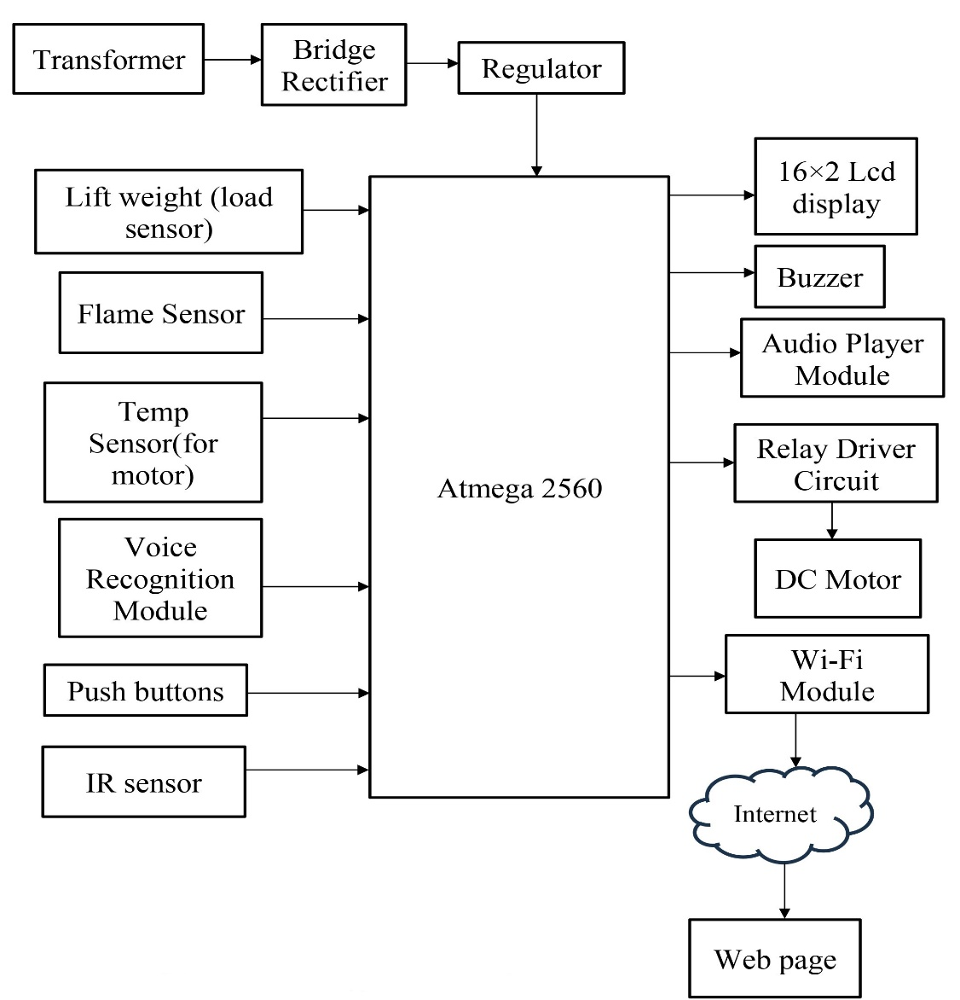

Fig.1: Block diagram of voice operated lift system

**Amrutvahini College of Engineering, Sangamner Department of Electronics and Telecommunication Project Synopsis**

**Academic Year: 2023-24**

## List of Hardware and/or Software Tools-

## To implement this project we require following resources.

### Hardware:

* Atmega 2560 microcontroller- 8 bit, 16MHz clock, RISC arch, 256KB flash memory, 8KB SRAM with 4 UART’s, 16 channel 10-bit ADC [11].
* Regulator- for regulating dc voltage to 5V
* Load sensor- for measure weight of lift unit
* Flame Sensor- for detection of fire in lift
* Temp sensor- for measuring temp of motor
* Voice recognition module- for recognition of speech and conversion to commands
* Push buttons- for buttons of lift
* 16×2 Lcd display- to display floor number, emergency message, etc.
* Buzzer- sounds when lift arrives as respective floor
* Audio player module- to tell feedback messages to user of lift
* Relay- as a motor driving circuit
* DC motor- to move the elevator up and down
* Wi-Fi module- for sending data to server for displaying on webpage

### Software:

* Arduino IDE- To program the microcontroller
* PCB wizard- for pcb designing
* Web page- using Html, CSS, JS

## References:

## Dilip Mathuria, Aditya Gaur, Ashish Gupta, “FPGA Implementation of Biometric based Elevator Controller”, IJETSR Volume 5, Issue 3, March 2018

1. Farouk Salah Mohamed Saod, Dr Maher Abdel Aziz, “Elevator for blind people using voice recognition” International Journal of Scientific & Engineering Research vol 9 Issue 7,July 18
2. Kaladharan N, Assistant Professor ,Dept. of Electrical Engineering. Annamalai University, IJIRCCE, “A study of speech recognition” volume.3,issue 9,page 8030- 8034,September 2015.

## Komal Mahajan, Riddhi Nahar, Dhanali Khairnar, Shrutika Kinge, Sujata Suryawanshi, “Elevator Control Using Speech Recognition for People with Physical Disabilities” IJARIIE Vol-7 Issue-3 2021

## Rashmi P C, Amulya, A Karthik Shetty, “Voice Operated Intelligent Lift” JETIR February 2019, Volume 6, Issue 2

1. Thomas Mohan, Amrutha K, Anjana Anil Kumar, Helen Johson, Silsha K, “Voice Operated Intelligent Lift”, IRJET VOL. 05 Issue.06 June 2018.

## Malim Huzaifa Salim, Sami Jaitapkar, Faki Ziyaan, Kazi Ibrahim, “Voice Based Lift Control” IJRASET Volume 10 Issue V May 2022

**Amrutvahini College of Engineering, Sangamner Department of Electronics and Telecommunication Project Synopsis**

**Academic Year: 2023-24**

1. P.Cernys, V.Kubilius, V.Macerauskas, K.Ratkevicius, “Intelligent Control of the Lift Model” IEEE international Workshop on Intelligent Data Acquisition and Advanced Computing System: Technology and Applications 8-10 September 2003
2. Aishwarya Pokharkar, Niriksha Poojari, Harish Pawar , Amey Patil, “Voice Operated Elevator” IJISRT Volume 6, Issue 5, May – 2021
3. B. Swathi, Akshay S Prathap, Aiswarya V Kumar, Ranjitha R, Raviteja Kaki, “Implementation of Voice based Touchless Lift System” IJSRCSEIT Volume 7, Issue 4, July-August-2021
4. Datasheet of Atmega 2560 microcontroller.

## 

**Amrutvahini College of Engineering, Sangamner Department of Electronics and Telecommunication Project Synopsis**

**Academic Year: 2023-24**

## Project Type: Industry Sponsored/ Inhouse Any Other Details:

**Remark of Project Guide:**

## Remark of Project Coordinator:

**Remark of Head of Department:**

### Prof. V. R. Aware Dr. S. R. Jondhale Dr. R. P. Labade (Project Guide) (Project Coordinator) (Head, E&TC Department)